TERMS OF REFERENCE
Consultancy services for
supporting the digitalization activities of the National Administration "Romanian Waters" (NARW) through RAPID Project

IT Expert for NARW (Individual Consultant)

- Background
Romania has received a loan from the International Bank for Reconstruction and Development (IBRD) to support the implementation of the Rural Pollution Prevention and Reduction Project (RAPID Project).
The Romania Rural Pollution Prevention and Reduction Project is an initiative aimed at addressing environmental challenges in the rural areas of Romania. Focused on mitigating pollution and promoting sustainable practices, this project seeks to safeguard the country's rural landscapes, preserve natural resources, and enhance the overall well-being of local communities.
The Loan 9505-RO for the Project and it was ratified by Romania by the Law no. 332/2023 on November 7th 2023 and it became effective on December 13th, 2023. The project closing date is June 30th, 2028.
The objectives of the project are to strengthen the institutional capacity of selected public entities, monitor pollution in agriculture, and transfer knowledge on agricultural pollution reduction to participating farmers. The project consists of three components:
- Modernization of Public Institutions: Enhance the institutional capacity of the Ministry of Environment, Waters, and Forests (MEWF) to monitor, evaluate, and report investments, including those related to environmental aspects of the National Recovery and Resilience Plan (NRRP). This involves increasing the national capacity for monitoring, prevention, and reduction of pollution from agricultural sources in rural areas, including the National Administration "Romanian Waters" (NARW), the National Phytosanitary Authority (ANF), and the Directorate for Land Consolidation and Land Fund (DÎFFF) within the Ministry of Agriculture and Rural Development (MADR).
- Knowledge Exchange and Awareness: Facilitate knowledge exchange, awareness, and information/innovation transfer to participating farmers. This includes establishing model farms to promote best agricultural practices for pollution prevention and reduction. The project also involves creating national knowledge transfer networks and conducting information and awareness campaigns for the public regarding project activities, including other environmentally-focused interventions funded under NRRP.
- Project Management: Ensure effective project management to oversee and coordinate the various components and activities outlined in the project.
The project aims to create a comprehensive framework for addressing agricultural pollution in Romania, involving institutional capacity building, knowledge dissemination, and active participation of farmers in adopting sustainable practices.

Both the funded Project activities and the Project Management activities are including consistent digitalization interventions for NARW, such as the development of an extensive Laboratory Information and Management System, modules for data modelling on water management, GIS applications etc.

Information/background regarding the IT software situation at the level of NARW
- IT infrastructure
Within NARW, the folowing major IT infrastructure services are available:
- LDAP service – implemented by Microsoft Active Directory
- Mail Service – implemented by Microsoft Exchange

- Software/IT Applications
During 2009-2017, ANAR implemented the WIMS (Water Information Management System). Starting from 2018, it was no longer used at the ANAR headquarters for technical reasons. It currently operates with limitations due to outdated technology in only a few River Basin Administrations (RBA): RBA Jiu, RBA Olt, RBA Argeș-Vedea, RBA Siret, RBA Buzău-Ialomița, RBA Prut-Bârlad WIMS system is an integrated IT system, based on an architecture of application servers and databases distributed on 2 levels, communication between levels being realized through VPN. It has a web architecture, the applications being accessed through a standard web browser. The databases types used at NARW are: Microsoft SQL Server and PostgreSQL.

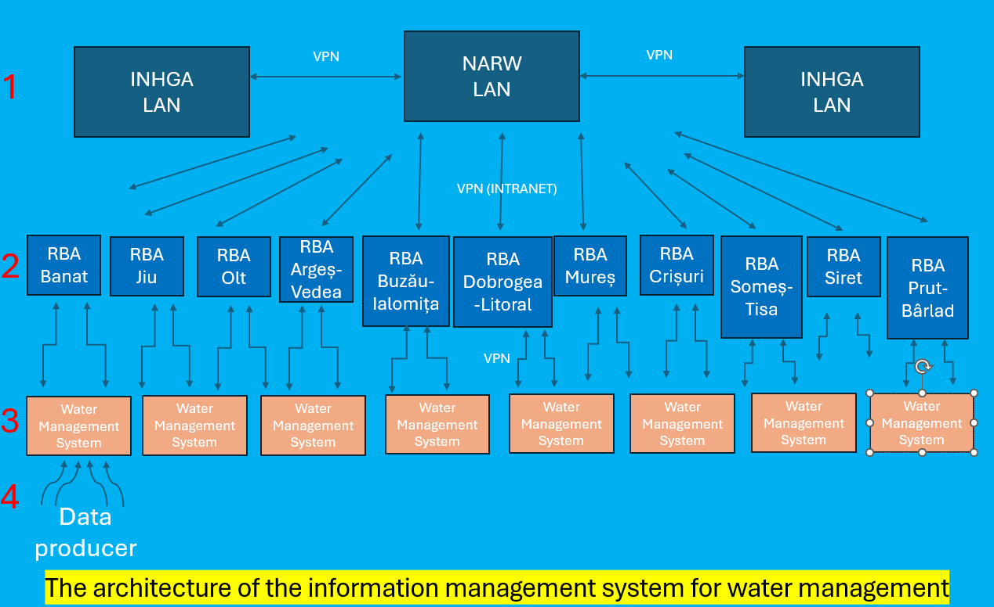

NARW owns several separately developped applications such as: (ECA-RO application, application for Urban waste water treatment, HydroMod, Mobapp, Hydra, Sintec, laboratory applications (LIMS).

Enterprise license agreement (ELA) GIS ANAR-ESRI
In the period 2017-2020, the Enterprise Agreement between NARW and ESRI Romania was implemented within NARW. Within this Agreement, the GIS infrastructure of NARW was developed by creating GIS portals at the level of ANAR and six River Basin Administrations, assigning ArcGIS Desktop licenses to GIS specialists, training courses for NARW and RBA employees. All GIS portals also contain relevant spatial data sets regarding nutrient pollution, surface water monitoring sections, groundwater monitoring sections, surface water bodies, underground water bodies, their evolution over time, etc., these being relevant for the Nitrates Directive and Water Framework Directive.
Having in view the national obligations as a member state of the European Union, Romania should develop and ensure the appropriate reporting exercises on the Nitrates Directive and also for Water Framework Directive. In this respect, the digitization and development of the water management field are crucial to achieving all European requirements. Moreover, the latest challenge of the domain is essential to be able to perform new types of assessments required by the several changes in policy.

Together with European requirements, we have to ensure the internal / national requirements, to be able to integrate the data and information of the water field in order to have an overview of the current status and also, to evaluate the risks of pollution as correctly as possible. All these activities have thus also a strong capacity building character.

The Ministry of Environment, Waters and Forests, as implementing institution, through the Project Management Unit for the "Prevention and Reduction of Pollution in Rural Areas Project" (PMU "RAPID") (named hereafter The Client), intends to contract an Individual Consultant (IC) for consolidating the NARW capacity to implement the digitalization activities, as foreseen under the RAPID Project.
Definitions of terms:
The Project / RAPID – Rural Pollution Prevention and Reduction Project
MEWF – Ministry of Environment, Waters and Forests
PMU – Project Management Unit – represents the unit established within the Ministry of Environment, Waters and Forests, that manages the implementation of the Rural Pollution Prevention and Reduction Project
NARW - National Administration "Romanian Waters"
The Contract – represents the contract to be signed with the awarded Individual Consultant
The Client – is the Ministry of Environment, Waters and Forests through the PMU RAPID
The IT Expert – the Individual Consultant that will be selected, based on the present Terms of Reference, to support the PMU with the implementation of all the digitalization related activities under the RAPID Project.

- Objectives of the assignment
Key objective of the consultancy services is to strengthen the NARW capacity on the implementation of digitalization activities under the RAPID Project.
- Scope of the Services
The IT Expert will closely coordinate his/her activity with the representatives of the NARW and PMU, as well with or contracted consultants, as instructed by the NARW or PMU, to implement, inter alia, the following digitalization activities:
- Preparation of ToRs/Technical Specifications (or consolidation of ToRs/Technical Specifications as provided by NARW) on IT software development / data modeling / procurement of IT hardware and providing support during development of bidding documents and tendering process (respond to requests for clarifications / questions from bidders, participation in pre-bid meetings etc.);
- Participation in evaluation / reception committees for IT software development / procurement of IT hardware / licenses;
- Ensuring technical coordination of the NARW IT activities / contracts financed through RAPID Project with the MEWF / Government / Special Telecommunication Services IT departments, including ensuring monitoring and reporting to NARW and PMU on progress and flagging risks and delays of relevant activities;
- Supporting software implementation activities such as providing guidance / training for the developed software for the end-users;
- Supporting NARW in working with GIS applications;
- Oversee and take part in ensuring Project visibility on the NARW’s website;
- Ensuring participation at various meeting, workshops, conferences or exchange of experience events, for promoting the PMU’s and NARW’s activities on digitalization and further analyze various options for improving the IT architecture at NARW level;
- Preparation of regular and ad-hoc reports for NARW and PMU on achieved progress and further needs on IT development, following the Project activities as included in the Procurement Plan, Aide-Memoires, contracts, etc.
- Supporting NARW on other IT needs for the monitoring and reporting on water management, as necessary.
- Consultant’s Profile
In order to be able to charge the Client for the activities performed under these terms of reference, the expert must either
- Be a person authorized under the Law no. 300/2004 regarding the authorization of individual persons and family associations to carry out independent activities
or
- act under a limited liability company or another form of organization that enables him/her to issue invoices for the services provided. I
In any of the cases, the Consultant should be aware that the services will be provided only by the selected Individual Consultant and no substitution of any individual who was initially selected, will be permitted.

The required qualifications and experience:
- At least the following qualifications: Bachelor degree/Master degree.
- At least 5 years’ experience in the development of large-scale/enterprise-level IT systems and hardware infrastructure for private and/or public institutions, including among others, demonstrated experience in:
    - Preparation of technical specifications on development / updating of IT systems and databases;
    - Business analysis, software development and testing of large-scale/enterprise-level IT software;
    - Experience in preparation of technical specifications for IT hardware / procurement of IT hardware.
- Will be considered an advantage, experience in:
    - IT security and enterprise architecture;
    - Administration and optimization of databases, as well as in the field of hardware and software architectures proven by the presentation of nationally/internationally recognized diplomas/certifications;
    - Developing software architecture;
    - GIS systems, Internet of Things (IoT) devices and networking;
    - Providing technical project/program management, including monitoring and reporting for the implementation of projects/programs is an advantage.
    - Programming languages such as JavaScript, HTML 5, Python, SQL and experience with middleware and integration tools;
    - Experience in the development of IT systems and/or hardware infrastructure for public institutions.
- Good command of spoken and written English is a must.

In case the Contract for this assignment will be awarded to a company that provides an individual consultant, only the qualification and experience of the individual consultant shall be evaluated, not the company’s experience. All the services/activities provided/delivered under this Assignment shall be delivered exclusively by the proposed individual consultant himself/herself.

- Duration of the assignment
The services under this Contract shall be provided until 31st of March, 2028, or any subsequent date, as agreed in writing by the Parties through a contract amendment.
The total input under the assignment is estimated at 3,200 working-hours (considering an average of 17 working days per calendar month, at an average of 4h per day).
This total input will be finally agreed during contract negotiations, subject to Client needs for the services, Consultant’s availability and the date of the commencement of services.
This planned estimated input is indicative being only an estimation and there will be no need for modifications of the contract through amendments, in order to adapt the working schedule, unless a substantial increase/decrease of monthly inputs will be agreed between the parties during contract implementation. It is estimated that the exact number of working hours per month to fluctuate, in accordance with the workload at the level of NARW.
The Work plan will be permanently adapted to the project implementation needs and will be agreed upon between the Consultant and the NARW. It will be detailed and carried over in the monthly time-sheets, which will provide a description of the activities carried out, of the deliverables provided and will specify the monthly total inputs effectively and actually performed.
Throughout the implementation of the Contract, the Client (through the NARW) and the Consultant will periodically establish the Work plan and the schedule of the following activities, through written or oral communications, including the estimated inputs for the future activities, as needed. The parties will keep track of the total inputs actually provided since the beginning of the contract, the total inputs provided during the reporting month and the remaining inputs out of the total inputs foreseen in the contract – data which will be reflected in the Consultant’s monthly report.
Payments will be calculated and made based on the total number of working-hours actually performed and delivered within each month.
Consultant’s monthly average input will be of about 68 working-hours (calculated as 4 working-hours/day x 17 days/calendar month). Even if the input is foreseen as a part time, the input per working day can normally range between 0-8 hours/day depending on the working schedule agreed between the Consultant and NARW. Thus, the monthly work-schedule may include time periods with 4 hours/working-day and time periods with higher or lower than the 4 hours/working day time-input, and also weekends and/or national holidays, if so agreed between the parties and depending on Consultant's availability and Client’s workload dictated by the project activities.
The contract will include a probationary period of 3 months, after which it may be terminated through a simple notification issued by the Client, without further details.
The consultant is expected to commence performance of the services preferably within 5 working days after contract signing.

- Reporting
Daily contract coordination will be ensured by NARW, in close cooperation with the PMU contract coordinator.
During this Assignment, the Individual Consultant shall deliver monthly progress reports which shall include monthly time-sheets (time-sheet which will have to be endorsed by NARW Contract coordinator).
All the Progress Reports shall be transmitted to NARW and to the PMU in one copy each, in Romanian language, signed by the Individual Consultant, together with the electronic versions (electronic mail/memory stick).
All the Progress Reports shall be submitted to the authorized representative of the Client (as designated by NARW), for initial analysis, after which the reports shall be submitted for the analysis and approval of the Acceptance Committee nominated by the Client.
The Individual Consultant shall consolidate the Progress Reports as requested by the Contract coordinators and/or afterwards by the Acceptance Committee, within maximum 2 working days as from receiving such requests, or within a longer period as agreed by the Consultant and the Client’s authorized representatives, if the circumstances require.
The Acceptance Committee shall decide upon the acceptance of the activities and deliverables provided by the Individual Consultant.
Based on the acceptance document of the final version of the Progress Reports, issued by the Acceptance Committee, the Individual Consultant shall issue the invoice and the Client shall pay, according to the Contract provisions.
At each 6 months, in line with the PMU Progress reports for the World Bank, the Consultant shall prepare a half-year report which shall include the deliverables and an activity plan for the next 6 months. The half-year report is without payment, but is a pre-condition for the following payments under the contract.

- Institutional arrangements, Data, Local Services, Personnel and Facilities to be provided by the Client
The IT Expert:
- Will work at the NARW premises (as requested and needed) with office equipment as ensured by the NARW. The Expert is allowed to work from his/her office only with the permission of the NARW, for no more than 50% of the total monthly working hours;
- Will work under the direct supervision and daily technical coordination of the NARW, and under supervision of the PMU Director and/or the PMU nominated experts;
- Will liaise with RAPID Project other contracted consultants and suppliers, as needed;
All documentation prepared by the Consultant during the course of the assignment will remain the absolute property of the Client. Not later than upon termination or expiration of the contract for the current assignment, the Consultant will deliver all such documentation to the Client.
The observance of the Fiscal Code provisions applicable in any of the legal forms under which the Individual Consultant will provide the services (either (a) limited liability company or another form of organization that enables him/her to issue invoices or (b) person authorized under the Law 300/2004), is the sole responsibility of the Consultant.
The Client will not pay or reimburse the Consultant for any other costs outside of the fees agreed for in the contract and the travel related expenses and, if approved by the Client in advance, other reimbursable type expenses incurred by the Consultant for the delivery of the services.
In case of travel outside Bucharest for meetings / workshops / conferences, any related costs incurred by the Consultant as for travel, accommodation, per-diem and as such, will be paid against supporting documents (for travel and accommodation) and at the level and in line with the thresholds approved for public administration for per-diem.
The Client shall provide to the Individual Consultant all the information necessary, concerning the purpose of this Assignment and that will be reasonably requested by the Individual Consultant in order to complete this Assignment.
The NARW and the Client will provide access to all relevant information, documents and stakeholders’ contact points to facilitate the implementation of the activities under this assignment, including NARW servers / network resources.

